DIGITAL AUDIOMETER

Digital Audiometer  the 1st fully digital and entirely computer-based  runs on Windows, Mac, Sun, Unix and Linux | 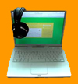

"The Digital Audiometer is working very nicely for my linguistic experiments. . . . the audiometer is doing exactly what I wanted it to do, and it is able to cut down on inter-rater variability since many different graduate students are assisting me in my project. I am very happy with it." Prof. Jenifer Larson-Hall, University of North Texas, USA
"The Digital Audiometer program is a great way to test the hearing of our study participants. It is fast and easy to use and the kids who we test actually think it is fun !" Kristin Stamm, UCLA (University of California, Los Angeles), USA
"The speech-language pathologists of the Annapolis Regional School Board have been using Digital Audiometer for over a year to screen the hearing of students grades Primary to 12. This software turns our laptop computers into audiometers so that we do not have to carry another piece of equipment with us into the schools. As itinerant specialists who have to travel from school to school, this is a real practical advantage. The software itself is easy to use either manually or in automatic mode." Dr.Christine.Sloan, SLP, Annapolis Regional School Board, Nova Scotia, Canada
"Digital Audiometer is remarkable for its simplicity, ease of use, error safeguards and reproducibility. ... Thank you for this truly phenomenal invention. ... It is every physician dream come true ..." Dr. Kingsley Ikpomwoba, Warri, Nigeria

Digital Audiometer is a computer software application for investigating hearing thresholds in a 0 Hz to 22,000 Hz frequency range and -20 dB to 100 dB SPL range. It runs on popular desktop hardware, including portable computers, and does not require any external or internal proprietary devices. It is very precise, easy to use, and due to the stability of digital circuitry, needs to be calibrated only once. | . | 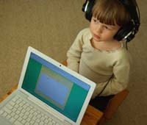

Digital Audiometer allows for a very accurate evaluation of hearing loss, auditory problems and capabilities.  Screening  and  Professional  versions available | Digital Audiometer Applications
  • | Ideal for those who perform standard hearing tests in clinics, schools or the workplace.
  • | Great value to audiologists, nurses and medical professionals such as ENT and family doctors.
  • | Its parameters make it an ideal instrument for research and teaching in the fields of acoustics, psychoacoustics, audio, electroacoustics, medicine, audiology and speech pathology.
  • | The expanded high-end frequency range in the Professional version makes it an ideal tool for testing ototoxicity that could be caused by exposure to chemicals, pharmaceuticals, and radiation.
  • | The expanded low-end frequency range in the Professional version allows for testing of middle ear disorders and infections.
  • | Very useful in fitting today's more advanced digital and semi-digital hearing aids.

Features
- Fully digital and entirely computer-based (any platform)
- Does not use any external or internal proprietary devices
- Fast, reliable and easy to use
- Portable, if installed on a portable computer
- Allows for all standard audiometric tests
- Offers a choice of automatic and manual testing
- Stores all audio signals in digital format
- Offers high precision and consistency of measurements
- Offers high quality and stability of the test signals
- Needs to be calibrated only once
- Allows easy generation of patient correspondence and audiogram printouts
- Allows electronic exchange of patient audiograms between audiologists or medical professionals

Parameters
Test signal type | Pure Tones and Warble Tones

Frequency range | 0 Hz to 22,000 Hz

Frequency resolution | 1Hz

Frequency stability | +/- 0.0001 Hz (at 1000 Hz)

S/N | 96 dB (in 16 bit systems)

Amplitude (SPL) range | -20 dB to 100 dB

Amplitude resolution | 1dB

Amplitude stability | +/- 0.0003 dB

Calibration modes | Aural with ± 3 dB precision and SLM-based with ± 0.1 dB precision

Test modes | Automatic and manual with instant display of threshold values. In automatic mode one can pre-select test frequencies for fast testing (for example 500 Hz, 1 kHz, 2 kHz, 4 kHz)

Harmonic and intermodulation distortions | None

  Demo
  For a demo of the Digital Audiometer please contact us directly. You can also visit WWW Hearing Test Screening for the Screening version, and WWW Hearing Test Professional for the Professional version. These web-based hearing tests have functionality similar to the Digital Audiometer.
  Test your
  Hearing
  Online
  WWW Hearing Test
  the first comprehensive and entirely web-based hearing test
.
Availability
The Digital Audiometer is available for Windows, Mac, Unix, Linux and NeXTSTEP.

Screen shot of the Digital Audiometer Screening version
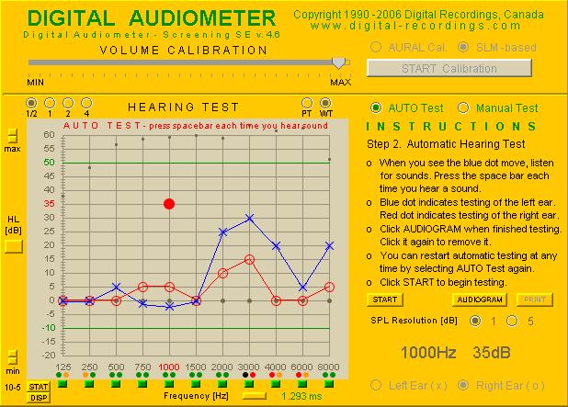

Screen shot of the Digital Audiometer Professional version
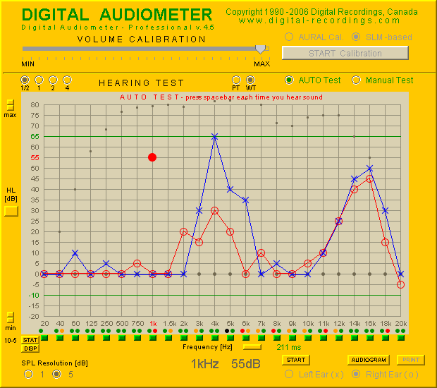

Interested in buying Digital Audiometer?
Digital Audiometer Screening version 1-computer license is offered at a price of $895 CAD plus shipping and handling and includes
- a free copy of Acoustical Calibrator DR1-R (value $59.95 CAD!)
- free software upgrades and technical support for 1 year
- 3 months satisfaction warranty.
Digital Audiometer Professional version 1-computer license is offered at a price of $1,195 CAD plus shipping and handling and includes
- a free copy of Acoustical Calibrator DR1-R (value $59.95 CAD!)
- free software upgrades and technical support for 1 year
- 3 months satisfaction warranty.
Digital Audiometer can be ordered via the Web by filling out this Secure Order Form.

Methods of payment include Visa, Master Card, American Express, money order or wire transfer. Orders will be filled after the funds are received.

